Software Requirements Specification

for

Overeaters Anonymous (OA)

Version 1.1

  
 **S**cott Evans  
**A**ndrew Lane  
**M**ichael Larsen  
**A**aron Parker  
**K**agen Wilkinson

**DATE: 08/15/2015**

Table of Contents

1. Introduction 1

1.1 Purpose and Intended Audience 1

1.2 Project Scope 2

1.2.1 Administration Module 2

1.2.2 Providers Module 2

1.2.3 Reports Module 2

1.3 Terms, Definitions, and Acronyms 3

1.4 References (see Appendix) 4

2. Overall Description 4

2.1 Product Perspective 4

2.2 Product Features 5

2.3 User Classes and Characteristics 5

2.4 Operating Environment 5

2.5 Design and Implementation Constraints 5

2.6 Assumptions and Dependencies 5

3. System Features 6

4. Non-Functional Requirements 6

4.1 FURPS+ 6

4.2 Feasibility Analysis 7

4.3 Cost-Benefit Analysis 9

5. External Interface Requirements 10

5.1 User Interfaces 10

5.2 Hardware Interfaces 10

5.3 Software Interfaces 10

5.3.1 Incoming and Outgoing Items 10

5.3.2 Services and Communications 10

5.4 Communication Interfaces 11

5.5 Stakeholders 11

5.6 Actors and Goals 11

5.6.1 Employee 11

5.6.2 Manager 11

5.7 Use Case Diagram 12

5.8 Use Case Casual Descriptions 13

5.9 Enter Provided Service Activity Diagram 14

5.9.1 Enter Provided Service Use Case Description 15

5.10 Manage Membership Status Activity Diagram 16

5.10.1 Manage Membership Status Use Case Description 17

6. Class Diagrams 18

6.1 Overview of Classes 18

6.1.1 Overview of Class Description 18

6.1.2 Overview Class Diagram 18

6.2 Domain Model for Employees 19

6.2.1 Domain Model for Employees Description 19

6.2.2 Domain Model for Employees Diagram 19

6.3 Domain Model for Providers 20

6.3.1 Domain Model for Providers Description 20

6.3.2 Domain Model for Providers Diagram 20

6.4 Domain Model for Members 21

6.4.1 Domain Model for Members Description 21

6.4.2 Domain Model for Employees Diagram 21

6.5 Domain Model for Reports 22

6.5.1 Domain Model for Reports Description 22

6.5.2 Domain Model for Reports Diagram 22

6.5.3 Reports Depiction 23

7. Sequence Diagrams 28

7.1 Add Member Sequence Diagram Description 28

7.2 Add Member Sequence Diagram 28

7.3 Add Provider Sequence Diagram Description 29

7.4 Add Provider Sequence Diagram 29

7.5 Enter Provider Service Sequence Diagram Description 30

7.6 Enter Provider Service Sequence Diagram 30

8. Communication Diagrams 31

8.1 Enter Provided Service Communication Diagram Description 31

8.2 Enter Provided Service Communication Diagram 31

8.3 Manage Membership Status Communication Diagram Description 32

8.4 Manage Membership Status Communication Diagram 32

9. State machine Diagram for Manage Membership Status 33

9.1 State Machine Diagram Description for Manage Membership Status 33

9.2 State machine Diagram for the Manage Membership Status 33

10. User Interfaces 34

10.1 Login Home page 34

10.2 Member Detail 35

10.3 Service Entry 36

10.4 Search 37

10.5 Search Results 38

10.6 Provider Directory 39

10.7 Contact Us 40

10.8 OA Administration 41

10.9 Report Generation 42

10.10 Web Application – Login Portal 43

10.11 Web Application - OA Administration 44

10.12 Web Application - Report Generation 45

11. Effort Breakdown Table 46

12. APPENDIX 47

Revision History

|  |  |  |  |
| --- | --- | --- | --- |
| **Name** | **Date** | **Reason For Changes** | **Version** |
| Andrew Lane | 7/9/15 | Initial Creation | 1.0 |
| Mike Larsen | 7/18/15 | Update terms, definitions, and acronyms | 1.0 |
| Mike Larsen | 07/21/15 | Use Case and Activity diagrams entered, update terms, definitions, and acronyms, update table of contents, update reference section, entered use case casual descriptions, updated appendix. | 1.0 |
| Aaron Parker | 07/22/15 | Use Case Descriptions entered | 1.0 |
| Mike Larsen | 07/22/15 | Update Use Case, Employee Class, and Reports Class diagrams | 1.0 |
| Scott Evans | 7/23/15 | Entered Introduction, Purpose and Intended Audience, Project Scope, Glossary, Overall Description, Product Perspective. | 1.0 |
| Andrew Lane | 7/23/15 | Added User Interface Design for Login, Service Entry, Provider Lookup, and Member Details. | 1.0 |
| Scott Evans | 7/24/15 | Added Sequence, Communication, and State Machine diagrams. Added Hardware Interfaces, Software Interfaces, and Communication Interfaces. Updated Glossary. | 1.0 |
| Aaron Parker | 7/24/15 | Added Feasibility Analysis, Cost-Benefit Analysis and FURPS+ to the Non-Functional Requirements | 1.0 |
| Kagen Wilkinson | 7/25/15 | Populated Overall Description and System features. Added report visuals. Reviewed/modified SRS for accuracy/clarity. | 1.0 |
| Andrew Lane | 7/25/15 | Added remaining user interface mockups | 1.0 |
| Andrew Lane | 7/26/15 | Added stakeholders as well as actors and goals. Updated team name from “Final Group 2” to SAMAK Tech. | 1.0 |
| Scott Evans | 8/10/15 | Added logo, updated Introduction, Purpose and Intended Audience, Providers Module, Reports Module, Glossary, Overall Description | 1.1 |
| Aaron Parker | 8/13/15 | Updated Chart in Cost-Benefit Analysis | 1.1 |
| Kagen Wilkinson | 8/13/15 | Updated SRS wording for admin module web app UI in 2.4, 2.5, 2.6, 5.2 and 5.3. | 1.1 |
| Andrew Lane | 8/13/15 | Added OA web application wireframes in section 10. | 1.1 |

# Introduction

Overeaters Anonymous (OA) is an organization that assists people in overcoming all types of food addiction. Which includes the following; compulsive overeating, anorexia, and bulimia. People that want this valuable service pay a $24 monthly fee to Overeaters Anonymous. Currently there are 1,500 members who can receive limitless consultations and treatments with providers that OA works with. Some of these providers include dietitians, internists, fitness trainers, massage therapists, and chiropractors. It also includes monthly gym memberships and fitness classes. There are currently 125 providers with hopes of increasing it with the new system.

When members sign up they receive a plastic card embossed with the member’s name, picture, and nine-digit number. The card also has a magnetic strip which contains this information that providers can scan to verify the member receiving the provider’s services. Once the service has been rendered Overeaters Anonymous reimburses the provider at an agreed upon fee and there is no cost to the member.

The current method is a manual process. A member goes into the provider and the provider calls Overeaters Anonymous to verify the member. Once the new system has been implemented, the hardware provided to the provider will verify the member status which will eliminate the manual process that is currently in place.

Over the last 10 years there has been a 5% increase in membership and only a 0.5% increase in providers. The new provider system has been projected to increase membership by 7.5%, with a 10% increase in provider participation within the first year. The estimated savings in administrative costs related to provider services will be 25% a year. Overall there will be a 12.9% increase in revenue each year for the next five years.

## Purpose and Intended Audience

The purpose of this document is to give a detailed description of the requirements for the Overeaters Anonymous application. It will explain the provider system that is being designed. This document is primarily intended to be proposed to a client for its approval and reference for developing the first version of the system for the development team.

## Project Scope

The system is represented in three main parts: Administration Module, Providers Module, and Reports Module. Below is an outline of each of these modules.

### Administration Module

The administration module allows Overeaters Anonymous employees to do the following:

* Add new members
* Update member records
* Inactivate member records
* Suspend member records whose dues are overdue
* Add providers
* Update provider records
* Inactive provider records
* Add or update provider services
* Run reports

### Providers Module

The provider module allows Overeaters Anonymous providers to use the provided hardware to render services to OA members. Once the service is complete the information will be sent to OA in order to reimburse the provider. This module allows providers to add entries for services rendered to OA members.

### Reports Module

The reports module runs automated reports to send out to members, providers, and Overeaters Anonymous account payable department. It also allows authorized users to run reports at any time. The reports module will generate the EFT file and send it directly to the financial institution.

## Terms, Definitions, and Acronyms

|  |  |
| --- | --- |
| Term | Definition |
| Application | A computer program with an interface, enabling people to use the computer as a tool to accomplish a specific task. |
| Class | In the real world, you'll often find many individual objects all of the same kind. There may be thousands of other bicycles in existence, all of the same make and model. Each bicycle was built from the same set of blueprints and therefore contains the same components. In object-oriented terms, we say that your bicycle is an instance of the class of objects known as bicycles. A class is the blueprint from which individual objects are created. |
| Database | A collection of information that is organized so that is can be easily accessed, managed, and updated |
| EFT | Electronic Funds Transfer |
| HTTP | Hypertext Transfer Protocol (HTTP) is the set of rules for transferring files (text, graphic images, sound, video, and other multimedia files) on the World Wide Web. Web browsers make specific use of HTTP. |
| Inheritance | Different kinds of objects often have a certain amount in common with each other. Mountain bikes, road bikes, and tandem bikes, for example, all share the characteristics of bicycles (current speed, current pedal cadence, and current gear). Yet each also defines additional features that make them different: tandem bicycles have two seats and two sets of handlebars; road bikes have drop handlebars; some mountain bikes have an additional chain ring, giving them a lower gear ratio. Object-oriented programming allows classes to inherit commonly used state and behavior from other classes. In this example, Bicycle now becomes the superclass of MountainBike, RoadBike, and TandemBike. |
| iOS | An operating system used for mobile devices manufactured by Apple Inc. |
| Live Filtering | A filtering process which filters results after every keystroke. |
| Module | A single part of a program that makes an entire system. |
| Object | In the class-based object-oriented programming paradigm, "object" refers to a particular instance of a class where the object can be a combination of variables, functions, and data structures. |
| OS | Operating system |
| SDK | Software Development Kit |
| Server | A computer that provides data to other computers/devices. |
| TCP/IP | Transmission Control Protocol/Internet Protocol is the basic communication language of the Internet. |

## References (see Appendix)

* Overeaters Anonymous System Description
* Meeting with the Client 7/20/15 9:30PM

# Overall Description

The system has been designed with three modules. These modules are the Administration Module, Providers Module, and Reports Module. The combination of these three modules will make up the structure of the system. The system will generate files that will be used in the EFT process which is handled by another vendor. The system will be able to interact with the existing Overeaters Anonymous database.

## Product Perspective

The Overeaters Anonymous application will allow for easier member and service validation within the organization. The administration module will allow employees to easily maintain members and providers. The reporting tools will allow employees to validate the status of members. The provider module will replace the current manual process with a streamlined automated one. Providers will be able to use the provided hardware to create and review service entries for members. The system will also generate the necessary weekly reports to send to corresponding recipients.

Payment

Processing

## Product Features

The product is designed to be a core management system with an administrative module providing the capability to create and manage, providers, members, and services. A provider module is also included, allowing for the added functionality in validating member activity status and the rendering of services. Finally, the reports module offers an array of weekly and/or on-demand member, provider, organization, and EFT reports that may be accessed and emailed.

## User Classes and Characteristics

The system’s users can generally be divided into Overeaters Anonymous staff (Employee) and provider staff (Provider). Basic skills with mobile devices and applications is assumed on part of the users to manipulate the terminal software appropriately.

## Operating Environment

This provider module is intended to be operated in mobile device form through a mobile application. The mobile app is designed to operate primarily through terminals located in the providers’ places of business though it may operate, under special circumstances, on the mobile devices potentially anywhere where a secure internet connection is established. An anchoring device will be utilized to assure that the provider terminal remains stationary as the devices are not intended to leave the provider’s place of business under normal circumstances.

In addition to the mobile application designed for the provider module, there is also a web based application designed for use by internal OA personnel. This application will be suitable for use on up-to-date versions of Chrome, Firefox, Internet Explorer, and Safari.

## Design and Implementation Constraints

The mobile application is to be developed for iOS 8.4 (Apple Operating System). As a result, Apple devices (iPad) will need to be acquired for distribution to members and OA staff since an application developed within an Apple OS may not be run on any other operating system.

The web based application is designed for use through an up-to-date version of Chrome, Firefox, Internet Explorer, or Safari. There are no other design constraints.

## Assumptions and Dependencies

The system is being developed as an application for the iOS 8.4 operating system. Apple applications may only be run on a device running the iOS operating system. It is assumed that the client will provide appropriate hardware terminals for providers upon which the application will be installed. Basic mobile device and touch screen usage knowledge is assumed for system users since the system interface is through a mobile application.

The web application assumes connectivity to the OA intranet and has no dependencies.

# System Features

The system is designed as a core system for Overeaters Anonymous and provides functionality for both OA staff as well as provider staff.

OA Employee Functionality:

* Manage (Add, Update, Activate, Inactivate) Member

Extended OA Manager Functionality:

* Manage (Add, Update, Activate, Inactivate) Provider
* Manage (Add, Update, Delete) Service
* Generate Report (Member, Provider, EFT)

Provider Functionality:

* Validate Member Status
* Enter Provided Service

# Non-Functional Requirements

## FURPS+

* **Functionality**

Secure firewalls for provided wireless systems, reliable card reader, ability to process member cards and catalog summary reports

* **Usability**

Simple user-friendly screens, use only necessary data, clear instructions, help tabs for increased user understanding

* **Reliability**

System backup if system failure, accurate member status output, error tolerance, modifiable during working hours

* **Performance**

Support number of coexisting users, instantaneously fast validating and getting results within seconds, Practical capacity as number of members and providers grow

* **Supportability**

Scheduled system maintenance, Back-up system for failed transactions, Updateable

* **Design Requirement**

System must be Wireless Capable

* **Implementation**

Policy for database integrity

* **Interface**

OA database interaction

* **Physical**

There is a need to be small to coincide with existing equipment

## Feasibility Analysis

**Technical Feasibility**

Functional Familiarity

* + The system screens will be fairly simple and user friendly to assist providers with easy interactions with the members and the new system

Technologic Familiarity

* + Using a touch screen tablet with on screen keyboard is common to most cell phones making the transition to this system easy and low-risk

Project Size

* + While this is a new system in itself, it will be interacting with a preexisting database keeping the actual project size on the lower end and keeping the cost down

Compatibility to existing tech

* + To keep from interfering with the providers normal business functionality this system will stay separate from providers other equipment and systems

**Economic Feasibility**

**Cost-Benefits Analysis**

Development cost

* + Equipment such as tablets for all provider offices and card readers will be an initial cost. Developing of the application along with the software licensing, designing, implementation, and training will also add on to the total cost

Annual Operating cost

* + Costs of operation will decrease by 25% helping with the overall return of the investment

Annual Benefits

* + Each year the revenue will increase 12.9% with estimated annual revenue of more than $958,000 by year 5

Intangible benefits

* + Increasing customer service by creating easy record filing and fast member validation, this new system will generate customer retention creating more proceeds for OA.

**Organizational Feasibility**

Project champion

* + If the cost-benefit analysis is positive and customer service is improved than there will be success with the Project Champion

Management/Receptionists

* + This system is to increase usability and simplify the process for the users allowing easy access to reports and catalogs, increasing desire to use the system.

Providers

* + Speeding up the process for validating OA members will increase provider’s satisfaction with working with OA and improve customer service

Members

* + Speeding up the process for validating OA members will also increase OA member satisfaction and improve customer service

Alignment with the business

* + The goal of this system and business is to provide quality services while increasing processing speeds. Also keeping records secured, accessible and organized is a must.

**Risk Factors**

* + Estimation of cost verses benefits may not be accurate
  + Requirements may be more widespread than originally specified
  + There is a chance for scope-creep
  + There is a chance end-users may not like the system
  + Going past the estimated finalized date

## Cost-Benefit Analysis

The resulting cost-benefit analysis represents the cost accumulated and benefits received within the next five years after system implementation. As the estimate is calculated the break-even point will be in 4 years and at five years the system monetary return including intangible benefits will be 60.5% more than the cost invested.

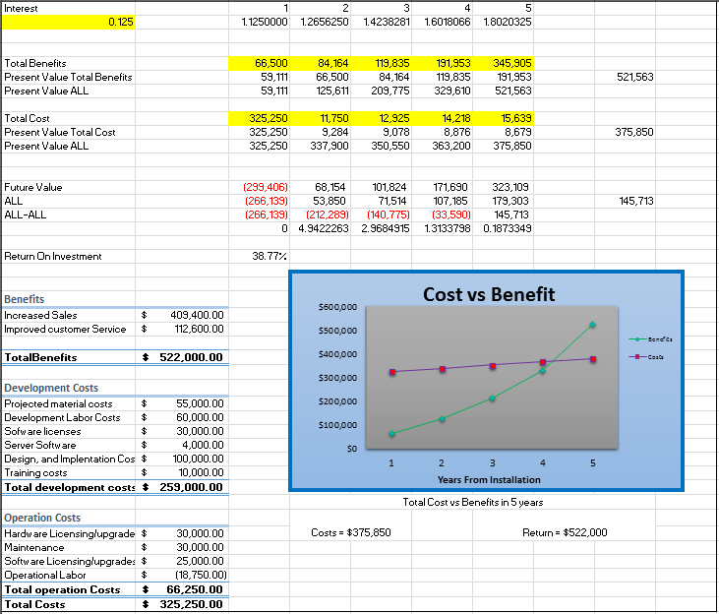

# External Interface Requirements

## User Interfaces

The following user interface wireframes are based off of the iPad hardware interface (section 5.2).

## Hardware Interfaces

The Overeaters Anonymous provider module application is intended as an iPad application for the Apple format. It is solely supported by Apples devices. Messages, updates, and data exchanged between Apple devices are transmitted to and handled by the Overeaters Anonymous server. The OA system is being developed for iOS 8.4 and all versions released after it. The Apple platform supports push message that will be used to synchronize data between the local application and the main application server. Information will be sent using TCP/IP and the HTTP protocol.The web application for the administration module is intended for use through computers connected to OA intranet.

## Software Interfaces

The Overeaters Anonymous provider module application is to be developed under the Apple iOS operating systems using the xCode and the iOS SDK (software development kit) tools. The administration module will be developed in HTML, CSS, and JavaScript.

### Incoming and Outgoing Items

* Outgoing data consists of provider information, bills, and confirmations sent by providers to the server.
* Incoming data consists of updates from the OA server regarding member status, as well as any other data deemed necessary

### Services and Communications

* Overeaters Anonymous application relies on server push and pull protocols to be fully functional
* Communication will occur in occasional between the provider’s hardware and the server in the following situations:
  + Whenever a member card is swiped
  + Whenever a new provider service is submitted
  + The application will notify the server when it successfully receives an update

## Communication Interfaces

The Overeaters Anonymous application has a network server that is web-based that allows the retrieval of a product directory from the database and calculate fees for services. The product also calls a database system that stores information between members and providers. The HTTP server will use a push protocol to push notifications of updates onto the provided hardware. Furthermore, whenever a provider opens the Overeaters Anonymous application from the provided hardware, a pull protocol will be used to retrieve and sync the latest transaction updates from the server.

## Stakeholders

There are several individuals who have an interest in this system. These stakeholders include: Overeaters Anonymous, Overeaters Anonymous providers, Overeaters Anonymous provider managers, Overeaters Anonymous provider employees, and SAMAK Tech.

## Actors and Goals

The following actors are individuals who directly interact with the system.

### Employee

An employee is an initiating type of actor. An employee’s goals are to create service entries, and validate Overeaters Anonymous members.

### Manager

A manager is an initiating type of actor. A manager is similar to an employee in that they can perform the same tasks, however they have different goals. A manager’s goals are to generate reports, manage members, manage services, and manage providers.

## Use Case Diagram

## Use Case Casual Descriptions

* **Manage Providers:** This use case allows managers to add new providers, update current provider information, and deactivate current providers that are no longer being used or activate previously used providers to be used again.
* **Manage Members:** This use case allows employees to add new members, update member information, deactivate current members for cancelled subscriptions, suspend current members for non-payment, and reactivate members once membership is paid current.
* **Manage Services:**  This use case allows managers to add new services that will be allowed to be billed to OA by providers providing services to OA members, allows managers to update current service information and costs, and allows them to delete services that will no longer be allowed to be billed to OA.
* **Generate Reports:** This use case allows managers to run weekly reports manually for both members and providers, run the summary report which totals the services provided to member by providers and totals the costs associated with the services provided, and to generate the data necessary for EFT payments to providers.
* **Validate Member Status:** This use case is how providers check to make sure a member coming to their location to receive service is paid current to the standards of OA. Services provided to members that are not paid current to the standards of OA will not be paid by OA. This also allows providers to enter the service that has been provided to an OA member that is in good standing with OA.

## C:\Users\Mike\Documents\School\Weber State\Summer 2015\CS2450 - Software Engineering\Final\Diagrams\Activity Diagrams - Enter Provided Service Activity Diagram.jpegEnter Provided Service Activity Diagram

### Enter Provided Service Use Case Description

|  |  |  |
| --- | --- | --- |
| **Use case name:** Enter Provided Service | **ID:** 0001 | **Importance Level:** High |
| **Primary actor:** Provider | **Use case type**: Detailed, Essential | |
| **Stakeholders and interests:**  Provider: Wants to validate member as an OA customer | | |
| **Brief description:**  This use case explains functionality of how a Provider will run a member card and the system will validate the member. After validation, Provider enters additional information to record the service distributed | | |
| **Trigger:**  Provider swipes member card through the card reader that OA provided | | |
| **Relationships:**  Association:  Include:  Extend:  Generalization: | | |
| **Normal flow of events:**   1. Provider swipes membership card 2. System validates member    1. Validated Appears 3. Date is entered for the service 4. Provider Looks up appropriate Service Code 5. Provider Enters Service Code 6. Provider Validates Service Code Description 7. Once Service Code description is validated with Service Code Number Provider is free to add comments 8. System records Provided Service    1. Validated DOES NOT appear 9. System Exits | | |

## C:\Users\Mike\Documents\School\Weber State\Summer 2015\CS2450 - Software Engineering\Final\Diagrams\Activity Diagrams - Manage Membership Status.jpegManage Membership Status Activity Diagram

### Manage Membership Status Use Case Description

|  |  |  |
| --- | --- | --- |
| **Use case name:** Manage Membership Status | **ID:** 0002 | **Importance Level:** High |
| **Primary actor:** OA-Receptionist/Manager | **Use case type**: Detailed, Essential | |
| **Stakeholders and interests:**  OA Receptionist/Manager: Wants to keep status updated for billing and data integrity | | |
| **Brief description:**  This use case describes the actions an OA employee will make with the system to manage membership status of a member. | | |
| **Trigger:**  New member is added or Existing Member’s Status changes | | |
| **Relationships:**  Association:  Include:  Extend: Inactivate Member, Suspend Member, Activate Member  Generalization: Manage Members | | |
| **Normal flow of events:**   1. System determines if new member or existing member    1. If new member  * Add member   1. If existing member  1. Determine member Activity    1. If inactive member  * Activate member   1. If active member  1. View Bill Status 2. System Exits | | |
| **Subflows:** View Bill Status   1. Get Bill Status 2. If Bill not current  * Set Membership status to Suspended  1. If Bill Current 2. Determine level of Activity  * If unused set to inactive * If currently active  1. Exit System | | |

# Class Diagrams

## Overview of Classes

### Overview of Class Description

This diagram shows the relationships and interactions between the different classes and objects of the system.

### Overview Class Diagram

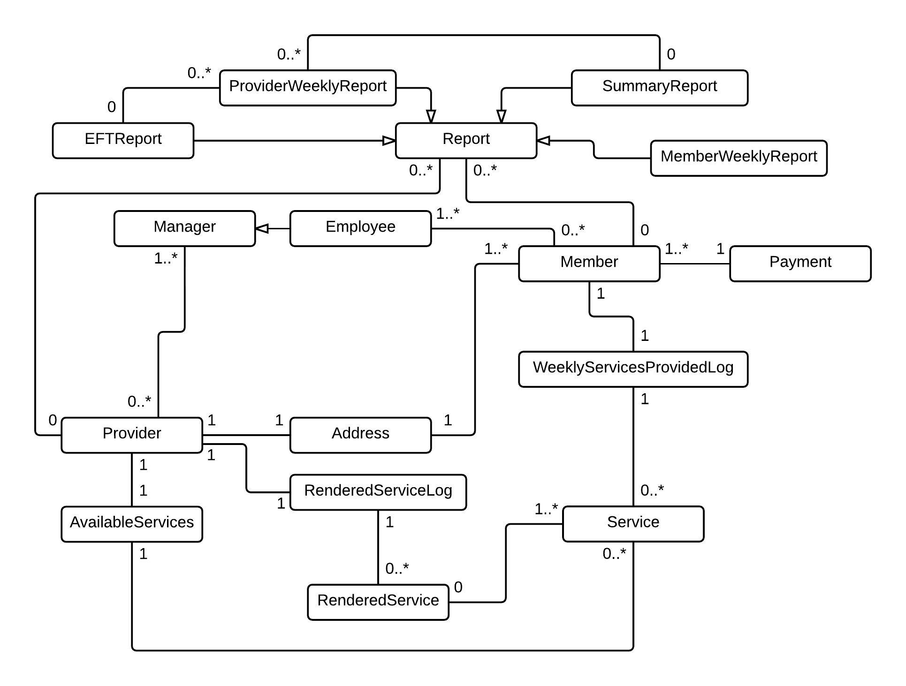

## Domain Model for Employees

### Domain Model for Employees Description

This diagram shows the inheritance with the employee class and other objects associated with the user class.

### Domain Model for Employees Diagram

## Domain Model for Providers

### Domain Model for Providers Description

This diagram shows the inheritance with the provider class and other objects associated with the provider class.

### Domain Model for Providers Diagram

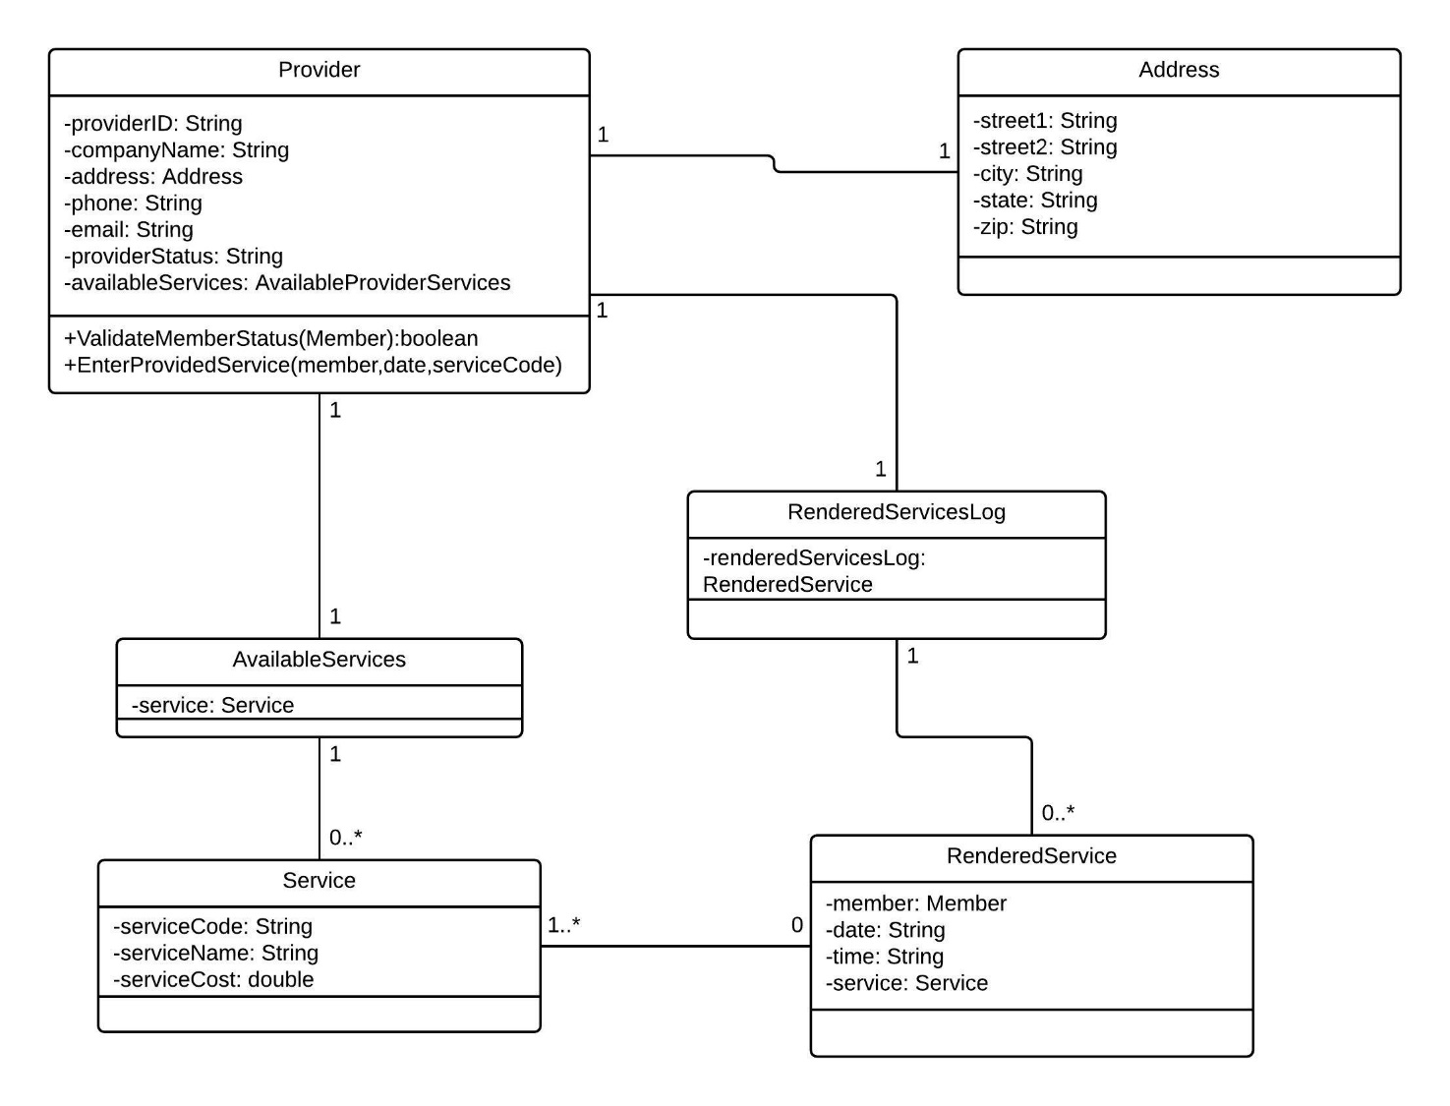

## Domain Model for Members

### Domain Model for Members Description

This diagram shows the inheritance with the member class and other objects associated with the member class.

### Domain Model for Employees Diagram

## Domain Model for Reports

### Domain Model for Reports Description

This diagram shows the inheritance with the report class and other objects associated with the report class.

### Domain Model for Reports Diagram

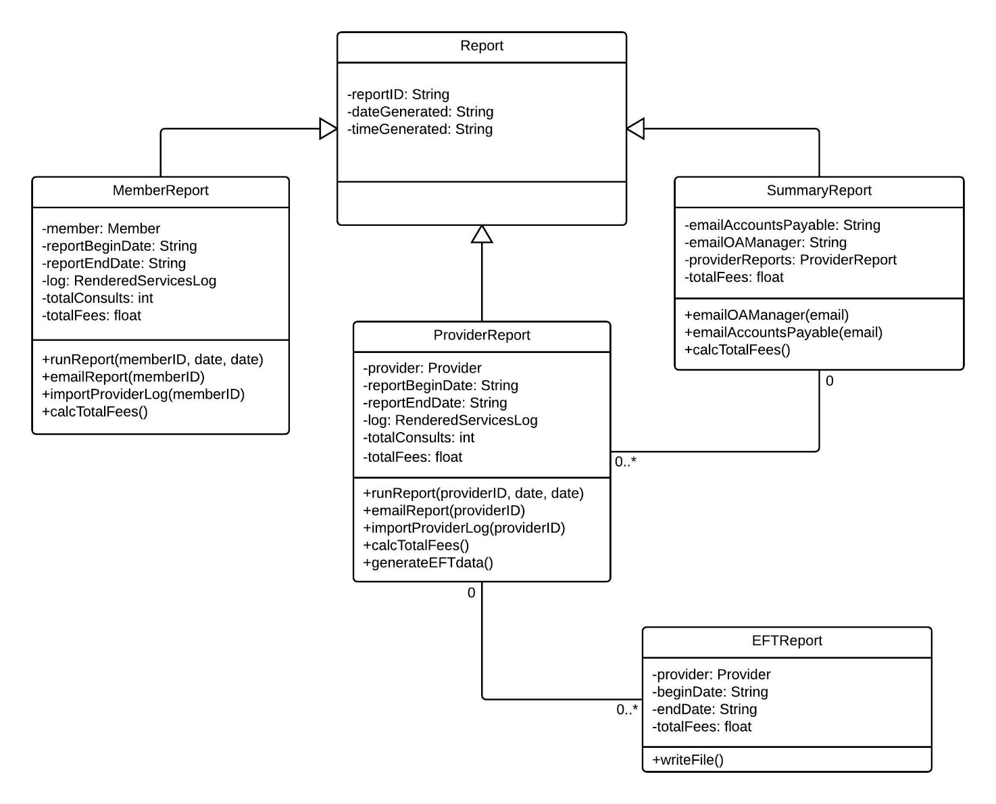

### Reports Depiction

Included in this section are visuals for the output versions of the reports. The output versions are text only to for the client’s and providers’ convenience, compatibility, and portability (i.e. export to spreadsheet) These reports contain random data for reference purposes and are designed based on the Overeaters Anonymous System Description (see appendix).

Member Report:

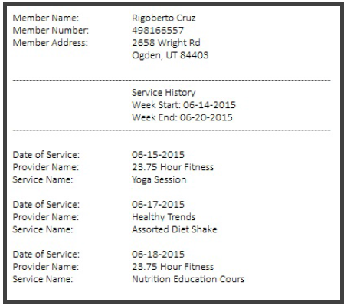

Service Record:

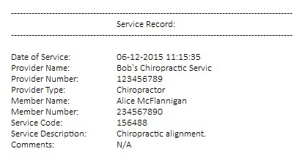

Provider Report:

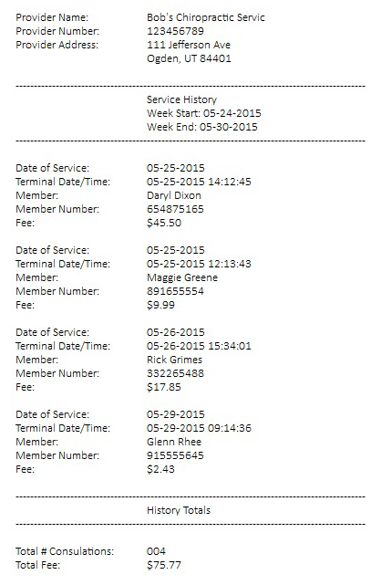

Summary Report:

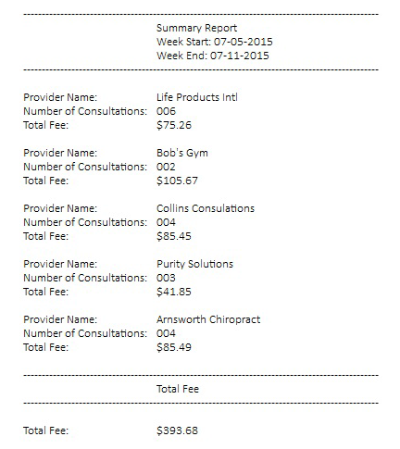

EFT Report:

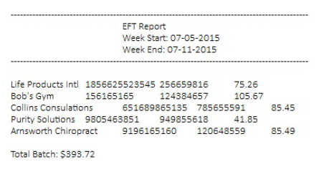

# Sequence Diagrams

## Add Member Sequence Diagram Description

This diagram displays the interaction between the actors and objects with other actors and objects and the information that is passed from one object to another when Add Member.

## Add Member Sequence Diagram

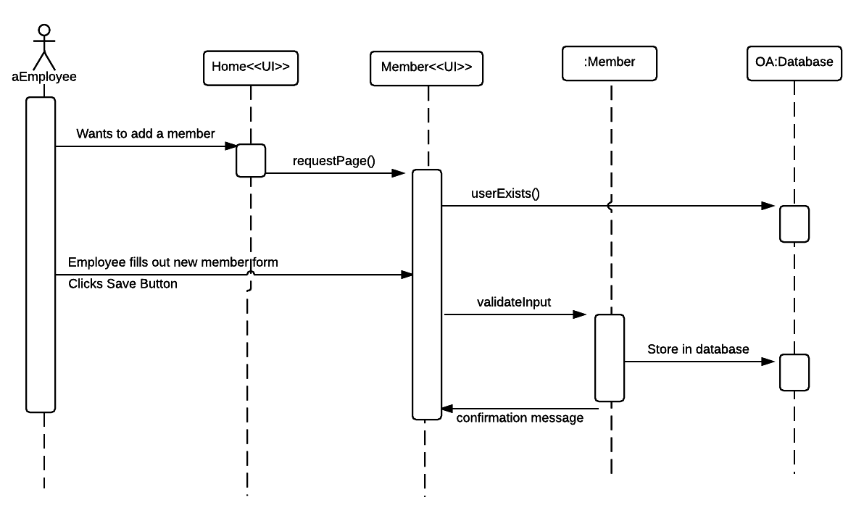

## Add Provider Sequence Diagram Description

This diagram displays the interaction between the actors and objects with other actors and objects and the information that is passed from one object to another when Add Provider.

## Add Provider Sequence Diagram

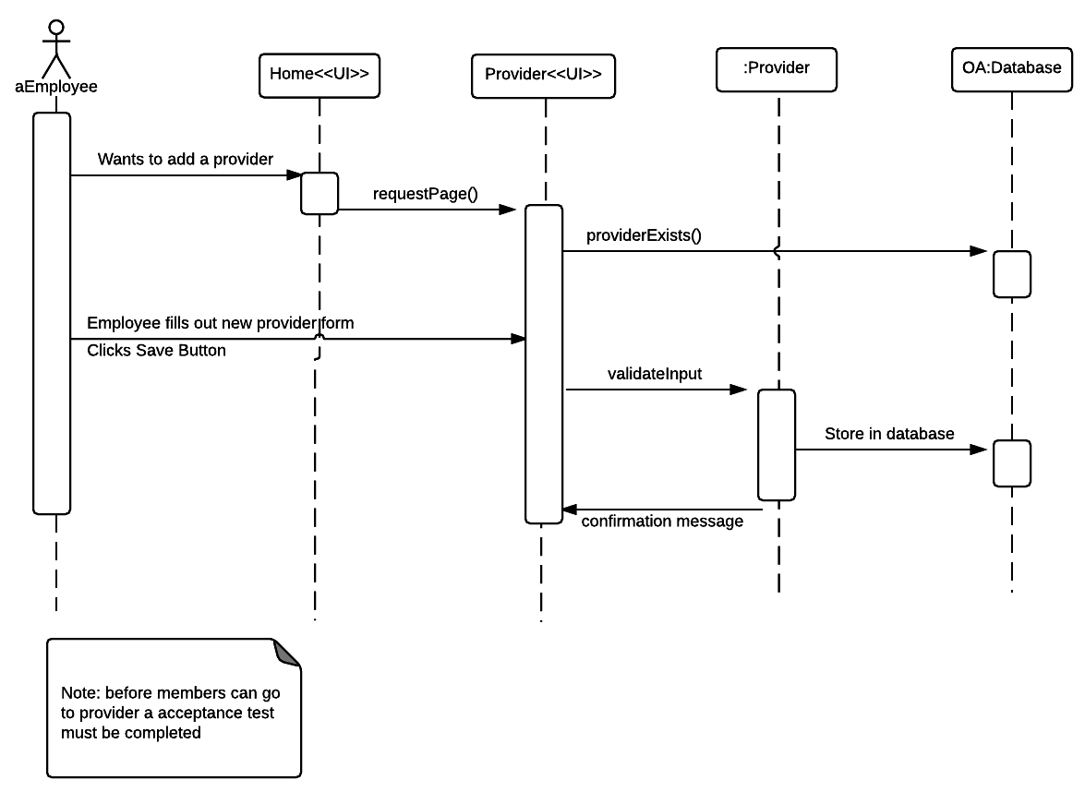

## Enter Provider Service Sequence Diagram Description

This diagram displays the interaction between the actors and objects with other actors and objects and the information that is passed from one object to another when Enter Provider Service.

## Enter Provider Service Sequence Diagram

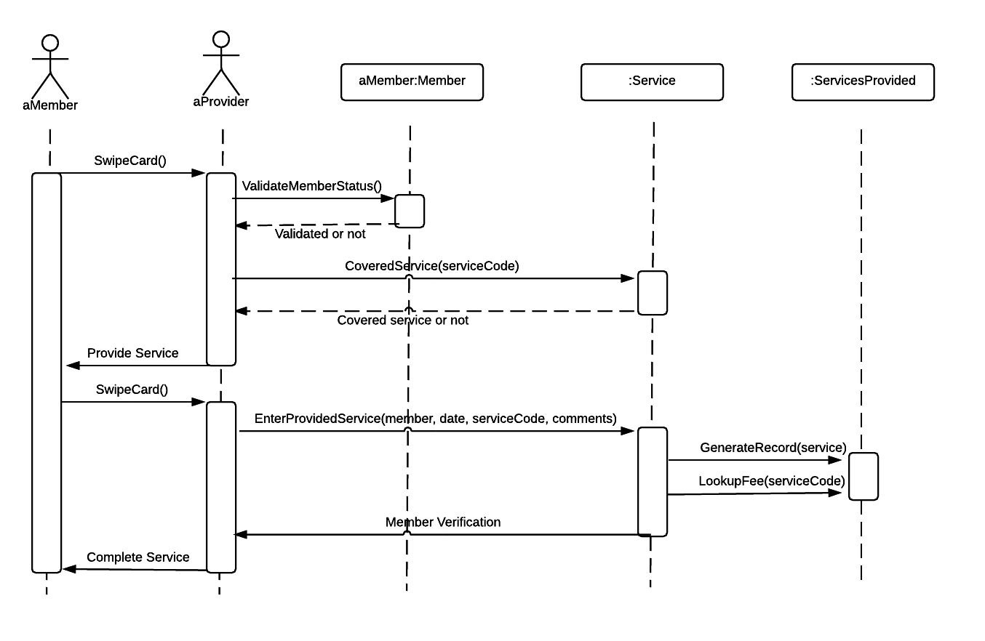

# Communication Diagrams

## Enter Provided Service Communication Diagram Description

This diagram shows how the members of the Enter Provided Service use case interact with one another.

## Enter Provided Service Communication Diagram

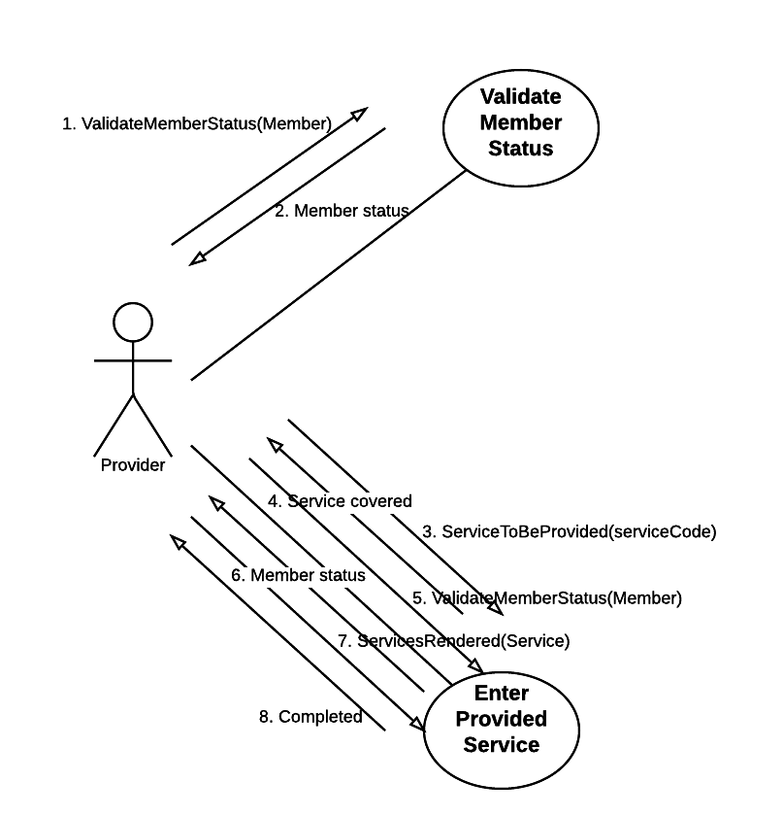

## Manage Membership Status Communication Diagram Description

This diagram shows how the members of the Manage Membership Status use case interact with one another.

## Manage Membership Status Communication Diagram

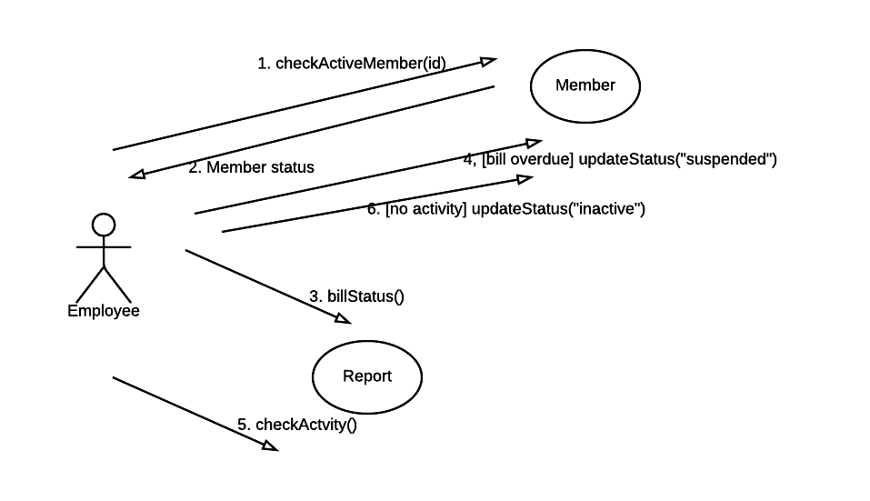

# State machine Diagram for Manage Membership Status

## State Machine Diagram Description for Manage Membership Status

This diagram displays the different states through with the Manage Membership Status goes through while it is active.

## State machine Diagram for the Manage Membership Status

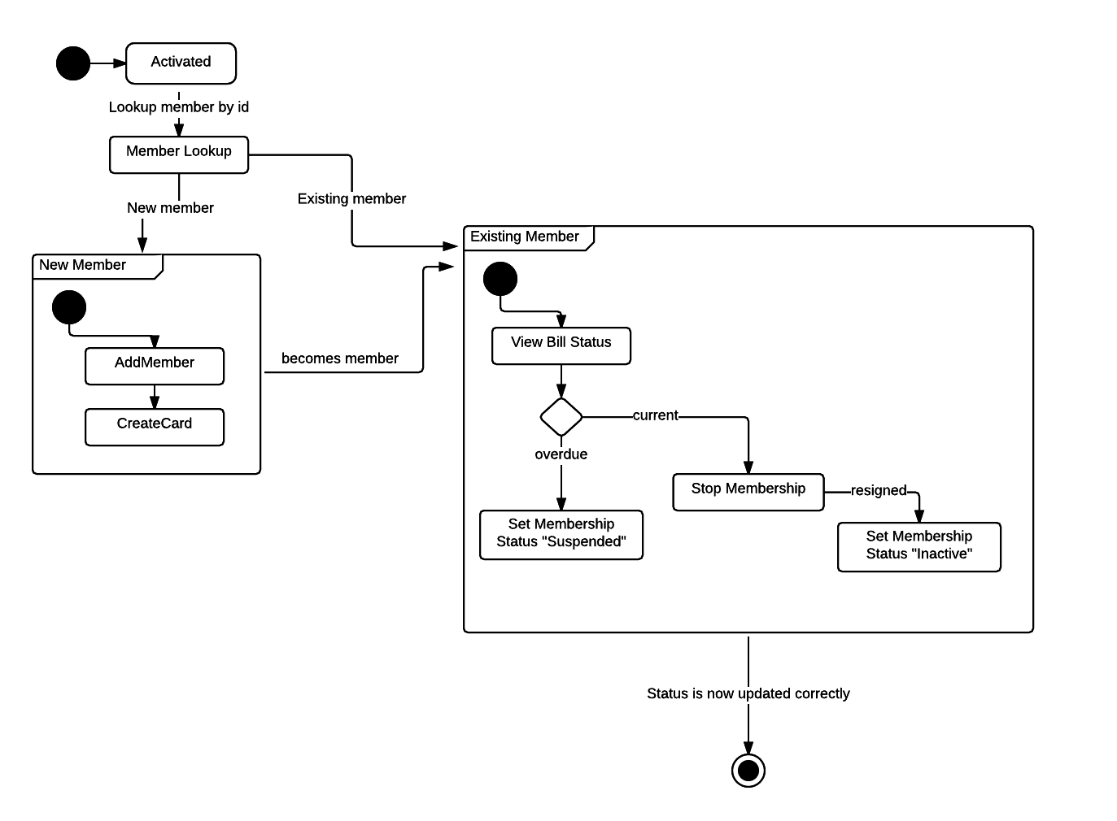

# User Interfaces

## Login Home page

The following user interface depicts the login screen or home screen. This screen is presented when the app is launched. The alert shown is toggled when the user clicks “Forgot Password”. Similar alerts are also displayed for invalid credentials.

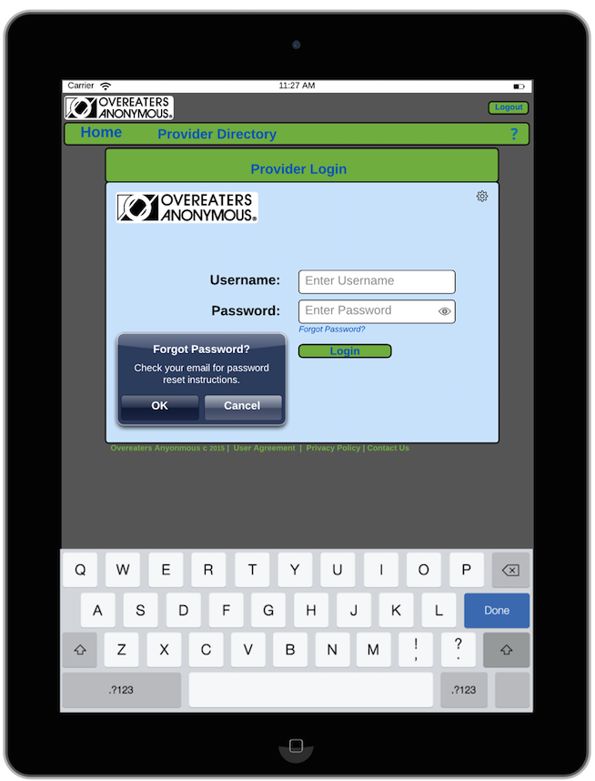

## Member Detail

The following user interface depicts the “Member Detail” screen. Assuming the provider has logged into the application, this screen is spawned after a member’s card swipe is received. Depending on the member’s current status with OA, this screen will indicate whether the user is, “Validated”, “Inactive Member”, “Invalid Member”, or “Member Suspended”. If the card swipe returns any status other than “Validated”, an error message will be thrown in the form of an IOS alert. From this screen, a provider can view the services OA covers. The provider can also create a service entry from this screen.

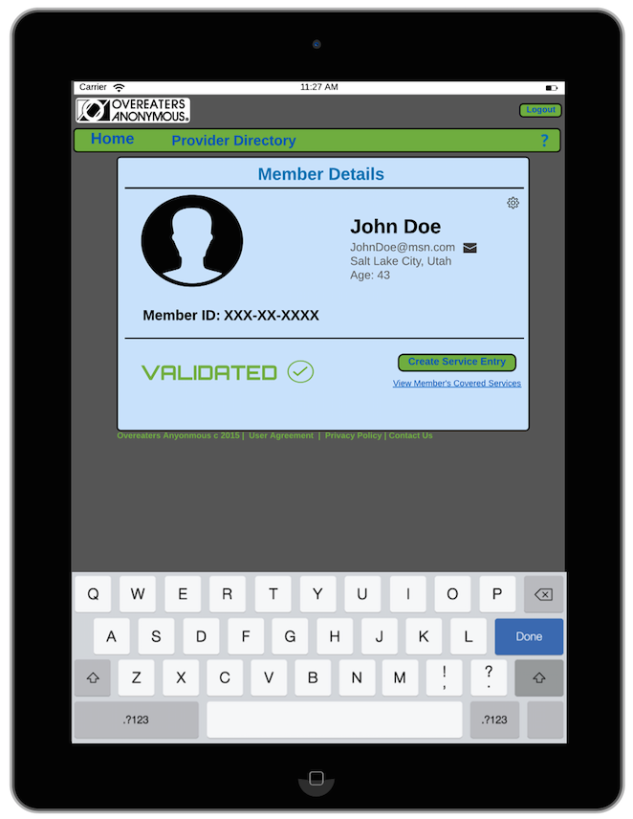

## Service Entry

The following user interface depicts the service entry screen. This screen can only be accessed if an OA member has a “Validated” status. This screen is used by the provider to create a service entry for the given OA customer. All relevant OA customer information will be prefilled on the service entry, along with the “Date of Service” and the “Provider Type”. Although these fields will be automatically populated, they can be edited. The “Service ID” field supports livefiltering to make it easy for the provider to pick the right service. If the provider cannot find the right service using the 6-digit identifier, they can click the “Find ID” button. Clicking this button will bring them to the “Provider Directory” screen. Lastly, when a user submits a new service entry, an alert will appear which requires the user to validate the service provided.

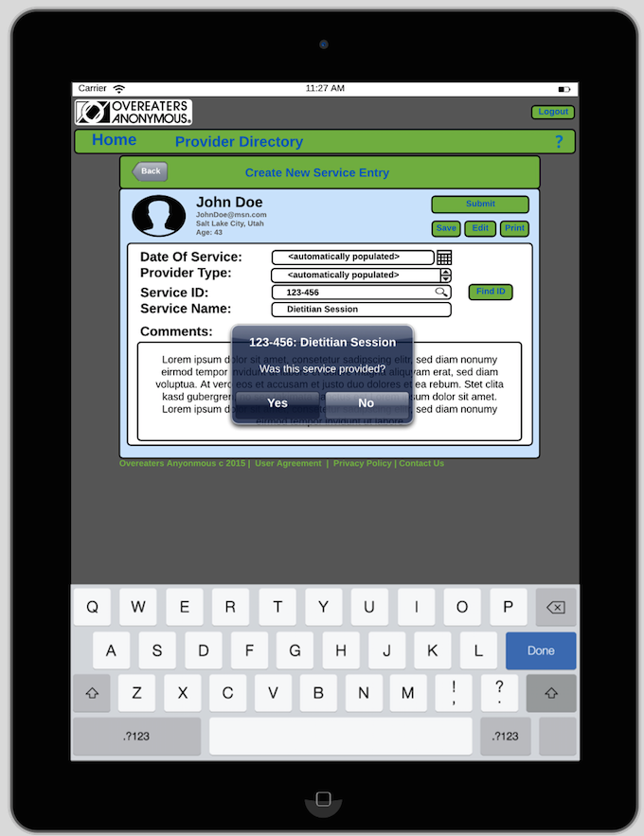

## Search

The following user interface depicts the “Search” screen. This screen can be accessed from the previous “Service Entry” screen via the “Find ID” button. A User will navigate here if they have trouble finding a “Service ID” or any other provider information. The user can enter one or many search parameters. Alternatively, they can view all provider information by clicking “View All”. The results are displayed on the “Search Results” screen.

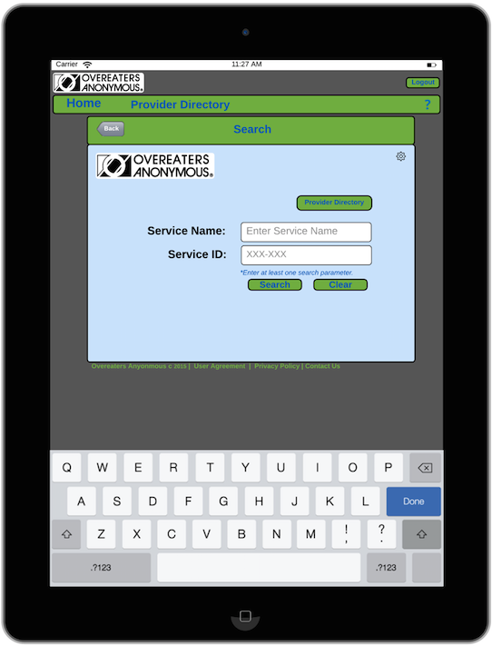

## Search Results

The following user interface depicts the “Search Results” screen. This screen is displayed after executing a search via the previous screen. All results are displayed in a paged list This screen displays all the services the given provider offers. The “Add to Service Entry” buttons only display if the user is in the process of creating a service entry. A user can also create a new search by clicking the “Create New Search” button in the lower right hand corner.

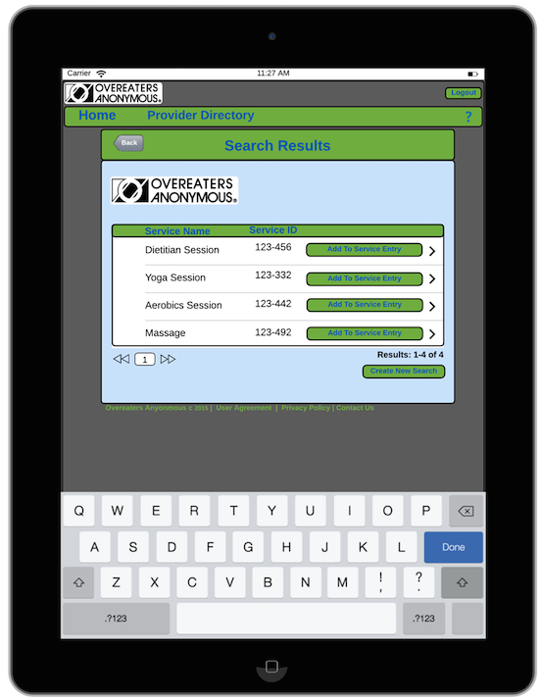

## Provider Directory

The following user interface depicts the “Provider Directory” screen. This screen can be accessed from the previous link in the menu bar, or directly from the “Provider Directory” button on the search screen. This screen displays all the services the given provider offers. The “Add to Service Entry” buttons only display if the user is in the process of creating a service entry.

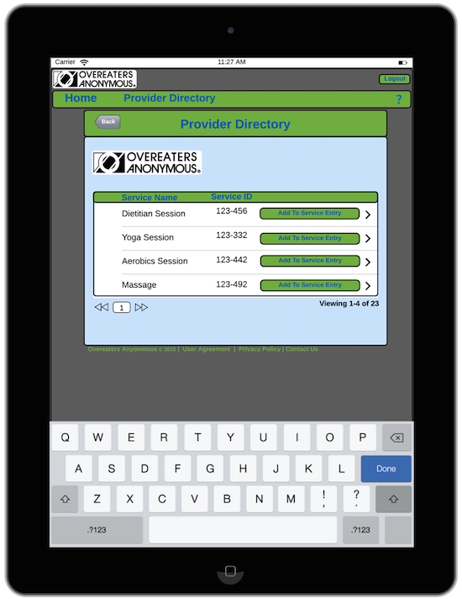

## Contact Us

The following user interface depicts the “Contact Us” screen. This screen can be accessed from the “?” link in the menu bar, or by clicking the “Contact Us” link at the bottom of any page. The screen allows the user to send OA a message and/or get OA’s contact information.

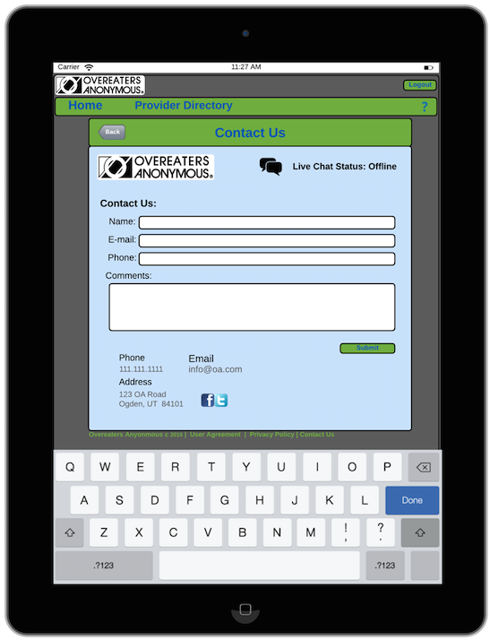

## OA Administration

The following user interface depicts the “OA Administration” screen. This screen can be accessed by clicking the “gear” icon which is present on many screens when a user has the necessary permissions. This screen allows a user to search existing data, or add/edit a provider, member, or service. The user will need to navigate to this screen first, in order to generate a report.

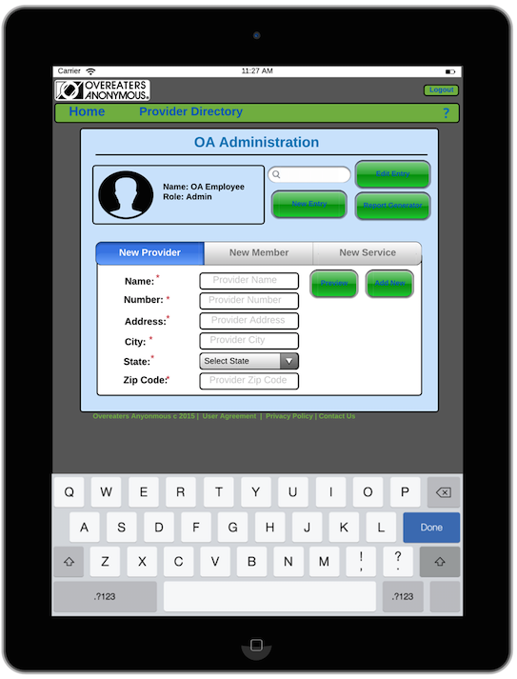

## Report Generation

The following user interface depicts the “Report Generation” screen. This screen is only accessible by OA administrators. This screen is accessed via the corresponding button on the “OA Administration” screen. This screen will let the user generate various reports. Based on the user’s needs, reports can be viewed, emailed (recipient information configured on “OA Administration” screen), or printed.

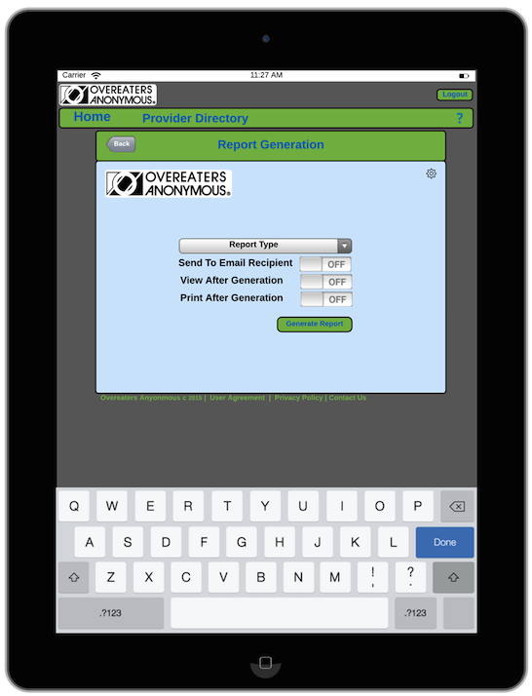

## Web Application – Login Portal

The following user interface depicts the login screen of the OA web application. This screen is rendered when the oa-online.com site is initially rendered. In order to use the admin functionality of this web app, the user must have valid admin credentials.

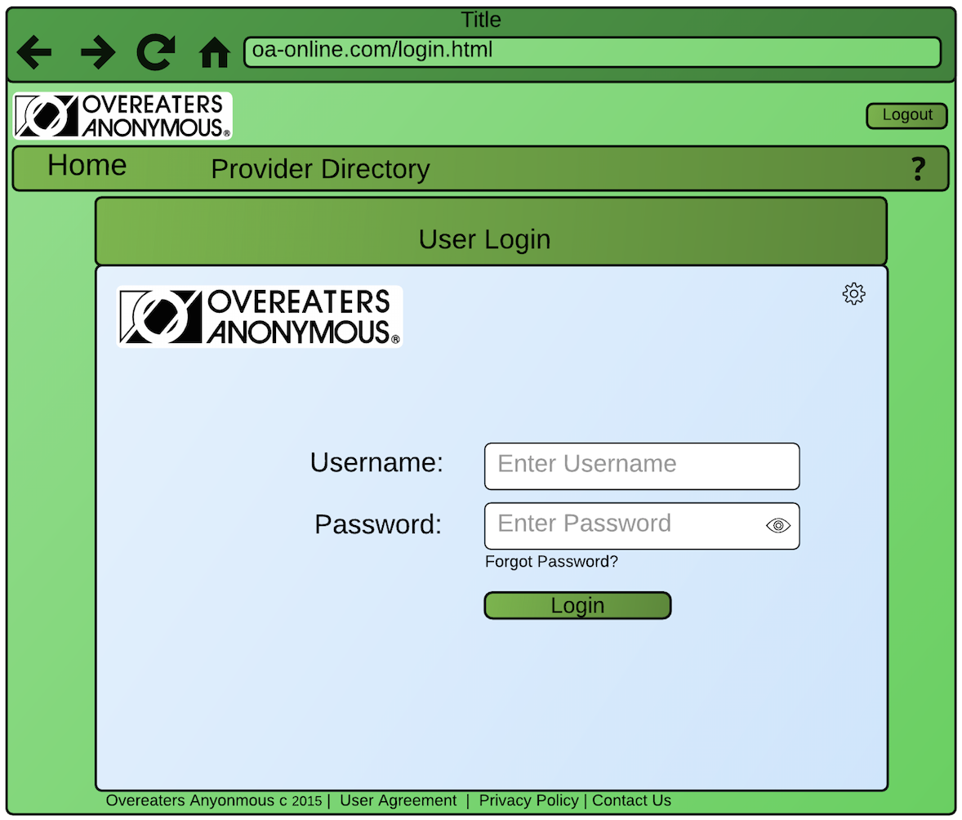

## Web Application - OA Administration

The following user interface depicts the “OA Administration” page of the OA web application. This page is rendered when a user logs in to oa-online.com with an administrator account. This page allows an admin user to search existing data, or add/edit a provider, member, or service. The admin will need to navigate to this screen first in order to generate a report.

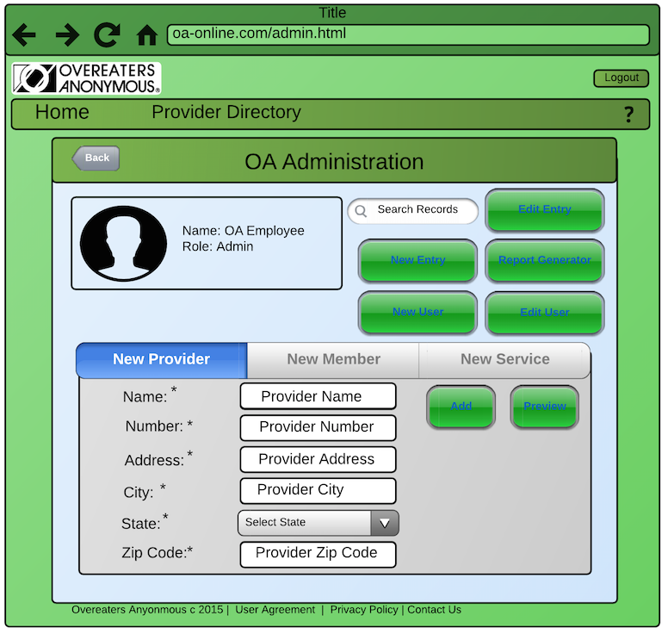

## Web Application - Report Generation

The following user interface depicts the “Report Generation” page of the OA web application. This screen can only be accessed via the corresponding button on the “OA Administration” page. This page will let the user generate various reports. Based on the user’s needs reports can be viewed, emailed (recipient information configured on “OA Administration” page), or printed.

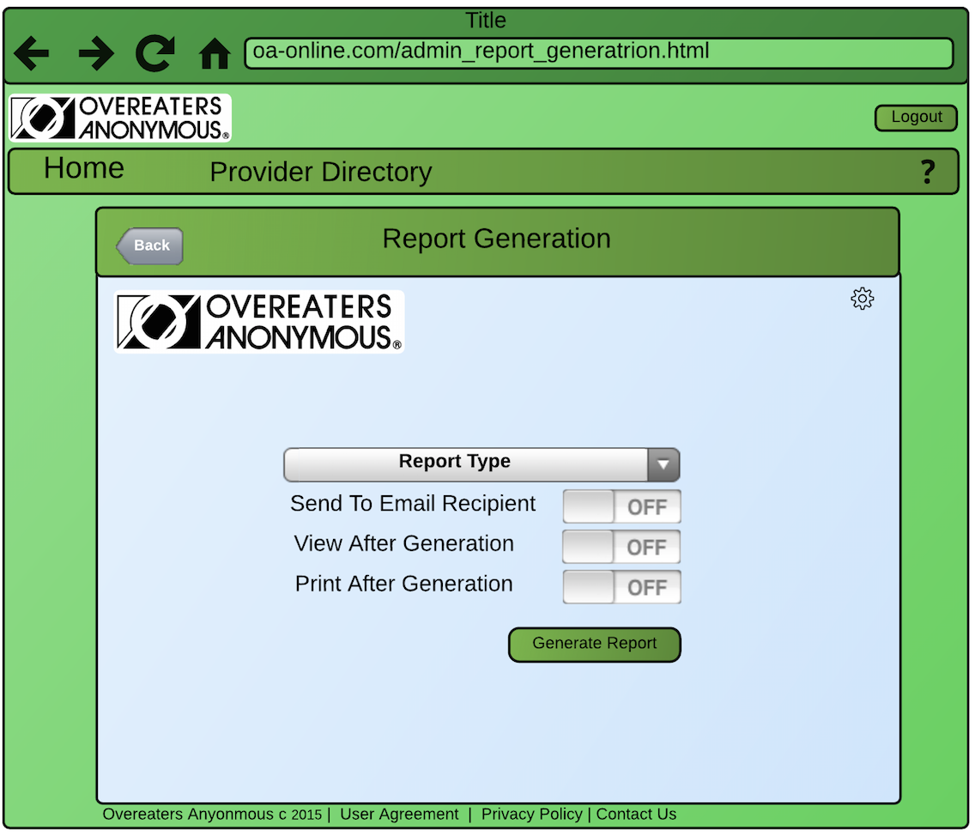

# Effort Breakdown Table

|  |  |  |  |  |  |  |
| --- | --- | --- | --- | --- | --- | --- |
|  | | **Team Member Name** | | | |  |
| Andrew | Scott | Michael | Aaron | Kagen |
| **Responsibility levels** | Customer Statement of Requirements  (9) |  |  |  | 60% | 40% |
| Glossary of Terms  (2) | 20% | 20% | 20% | 20% | 20% |
| Functional Requirements Specification (35) | 15% | 35 % | 35 % | 15 % |  |
| Nonfunctional Requirements (2) |  |  |  | 100 % |  |
| User Interface Design (11) | 80% | 10% |  |  | 10% |
| References  (1) |  |  | 100% |  |  |

# APPENDIX

**Overeaters Anonymous System Description**

Overeaters Anonymous (OA) is an organization dedicated to helping people overcome all forms of food addiction including compulsive overeating, anorexia, and bulimia.  Members pay a $24 monthly fee to OA. For this fee they are entitled to unlimited consultations and treatments with health-care professionals and other practitioners’, such as dietitians, internists, fitness trainers, massage therapists, and chiropractors, as well as monthly gym memberships and fitness classes.

Every member is given a plastic card embossed with the member’s name and a nine-digit number, and incorporating a magnetic strip on which that information is encoded.  Each health-care professional (*provider*) who provides services to OA members will have a specially designed OA computer terminal with a card reader installed in their place of business. In order to receive services from OA approved providers, the member hands his or her card to the provider, who slides the card through a card reader on the terminal. The terminal then connects to the OA Data Center, and the OA central computer verifies the member number.  If the number is valid, the word **Validated** appears on the display.  If the number is not valid, a reason is displayed; **Invalid number, Inactive member,** or **Member suspended** which indicates that dues are owed (that is, the member has not paid dues for at least a month) and member status has been set to suspended.

In order to bill OA after a service has been provided to the member, the provider again passes the card through the card reader or keys in the member number. When the word **Validated** appears, the provider keys in the date the service was provided in the format **MM-DD-YYYY**.  The date of services is needed because hardware or other difficulties may have prevented the provider from billing OA immediately after providing the service.  Finally, the provider uses the Provider Directory to look up the appropriate six-digit service code corresponding to the service provided. For example, 598470 is the code for a session with a dietitian, while 883948 is the code for an aerobics exercise session.  The provider then keys in the service code. To check that the service code has been correctly keyed in, the information system then displays the name of the service corresponding to the code (up to 14 characters) and asks the provider to verify that this was the service provided.  If the provider has entered a nonexistent code, an error message is printed. The provider also can enter any additional comments (up to 100 characters) about the service provided, if needed.

The information system then writes a record to disk that includes the following fields:

Current date and time (MM-DD-YYYY HH:MM:SS) Date service was provided (MM-DD-YYYY) Provider name (25 characters)

Provider number (9 digits, previously entered by the provider) Provider type (internist, dietitian, fitness trainer, etc.)

Member name (25 characters) Member number (9 digits) Service code (6 digits)

Description of service provided (40 characters) Comments (100 characters) (optional).

The information system next looks up the fee to be paid for that service and displays it on the provider’s terminal.  For verification purposes, each provider has been given a form on which to write the current date and time, the date the service was provided, name of member and member number, service code, and fee to be paid.  At the end of the week, the provider totals the fees to verify the amount to be paid to that provider by OA for that week.

At midnight on Friday, the main accounting procedure is run.  It reads the week’s file of services provided and generates a number of reports, which are emailed to the appropriate party.  Each report also can be run individually at the request of an OA manager at any time during the week.

Each member who has consulted an OA provider during that week receives a list of services provided to that member, sorted in order of service date. The report includes:

Member name (25 characters) Member number (9 digits)

Member street address (25 characters) Member city (14 characters)

Member state (2 letters) Member ZIP code (5 digits)

For each service provided, the report includes a line stating: Date of service (MM-DD-YYYY)

Provider name (25 characters) Service name (20 characters)

Each provider who has billed OA during that week receives a report containing the list of services he or she provided to OA members. To simplify the task of verification, the report contains the same information as is entered on the provider’s form, in the order that the data were received by the computer.  At the end of the report is a summary including the number of consultations with members and the total fee for that week. That is, the fields of the report include:

Provider name (25 characters) Provider number (9 digits)

Provider street address (25 characters) Provider city (14 characters)

Provider state (2 letters) Provider ZIP code (5 digits)

For each service provided, the report includes a line stating: Date of service (MM-DD-YYYY)

Date and time data were received by the computer (MM-DD-YYYY HH:MM:SS) Member name (25 characters)

Member number (9 digits) Service code (6 digits)

Fee to be paid (up to $999.99)

The final lines on the report include summary information for the week:

Total number of consultations with members (3 digits) Total fee for week (up to $99,999.99).

A record consisting of electronic funds transfer (EFT) data is then written to a file; banking computers will later ensure that each provider’s bank account is credited with the appropriate amount.

A **summary report** is emailed to the manager for accounts payable. The report lists every provider to be paid that week, the number of consultations each had, and his or her total fee for that week.  Finally, the total number of providers who provided services, the total number of consultations, and the overall fee are printed.

During the day, the information system is run in interactive mode to allow receptionists and/or managers to add new members, to update member records, to inactive members who have resigned, and to suspend those whose dues are overdue.  Similarly, provider records can be added, updated, or inactivated and services can be added or updated.

Your company has been contacted to provide an estimate for the software that will run on the provider terminals and the OA employee computers and connect to our existing database; other vendors will be responsible for the hardware involved with the provider terminals and the Internet connectivity, and for implementing the EFT component.

The contract states that at the acceptance test, the data from a provider’s terminal must be simulated by keyboard input and data to be transmitted to a provider’s terminal display must appear on the screen. A manager’s terminal must be simulated by the same keyboard and screen.  Each member report must be sent to its own file. The name of the file should begin with the member name, followed by the date of the report. The provider reports should be handled the same way. As for the EFT data, all that is required is that a file be set up containing provider name and number, the date, and the amount to be transferred.

Some financial information about Overeaters Anonymous

Statewide, OA currently has approximately 1500 members and 125 providers.

We have experienced a steady 5% increase in membership over the last 10 years and a very slow 0.5% increase in providers. Our revenue last year with memberships and private/corporate donations was approximately $532,000.

When the new provider system is implemented, we expect a 7.5% increase in membership, a 10% increase in provider participation during the first year alone, and a 25% decrease in administrative costs related to provider services. This will account for an overall 12.9% increase in revenue each year for the next five years.

**Client Meeting 7/20/15 9:30PM**

1. Does the $24 monthly fee include everything or are there extra costs for certain services that are provided?

*They pay to join and get access to everything always. There are no hidden fees no matter the service provided.*

1. How are members currently paying for their memberships? Are they paying online, over the phone, mailing in a check, automatic payments, etc?

*No online membership payment established. Pays by phone or check. Automatic online payments is something they are looking into but not a part of this system.*

1. Is it a contracted membership or something they are able to cancel at any time?

*No contract. Month to month. No proration for cancelling in the middle of the month. Cards are replaced in office free of charge.*

1. What is the format of the provider directory?  Is it electronic, paper, website, etc?

*Electronic look up through their website.*

1. What is the format of the verification form? Also, what is the purpose of the verification form? If the system provides reports at the end of the week, what is the purpose of the verification form?

*Optional process for provider. It is up to the provider to manage keeping a list for their own records.*

1. If the provider network connection is not available, what is their a backup process?

*Offices would call OA and veify member is active/current. The provider will not in the comments section when billing for the service who they talked to at OA to verify membership.*

1. What extra “powers” do managers have that receptionists do not?

*Mangers will be primarily in charge of taking care of things pertaining to providers and services. Receptionists in charge of membership needs.*

_________

Hardware has not yet been chosen… Suggestions would be in order before contracting the job.